目录

堆 2

哈夫曼树和哈夫曼编码 4

集合 8

图 10

# 堆

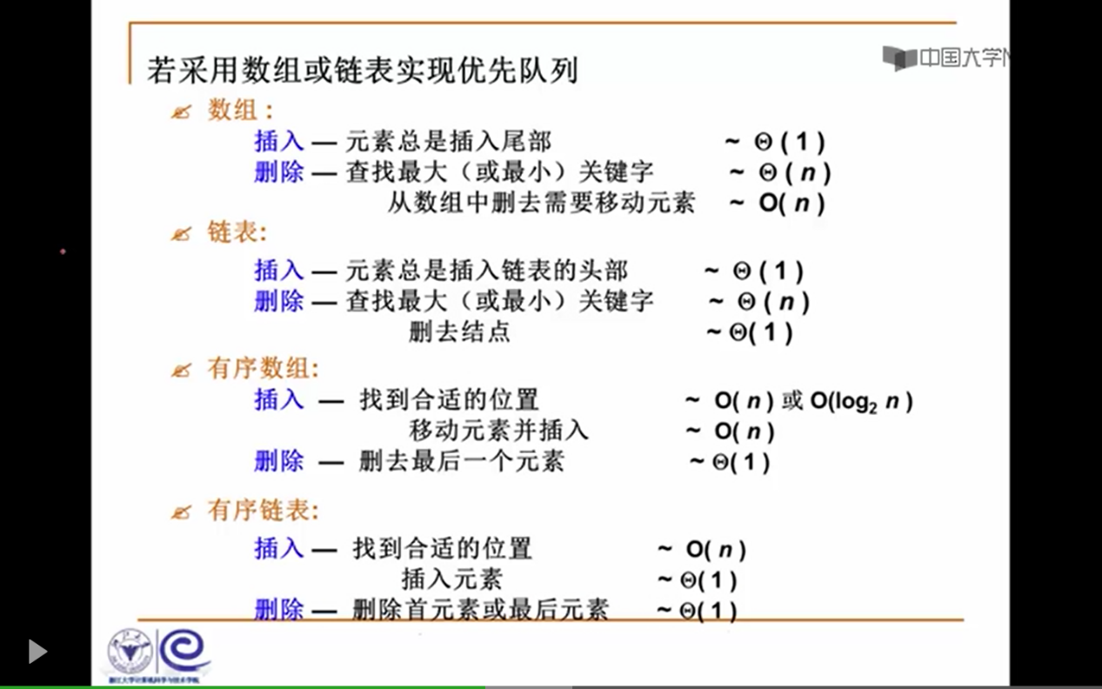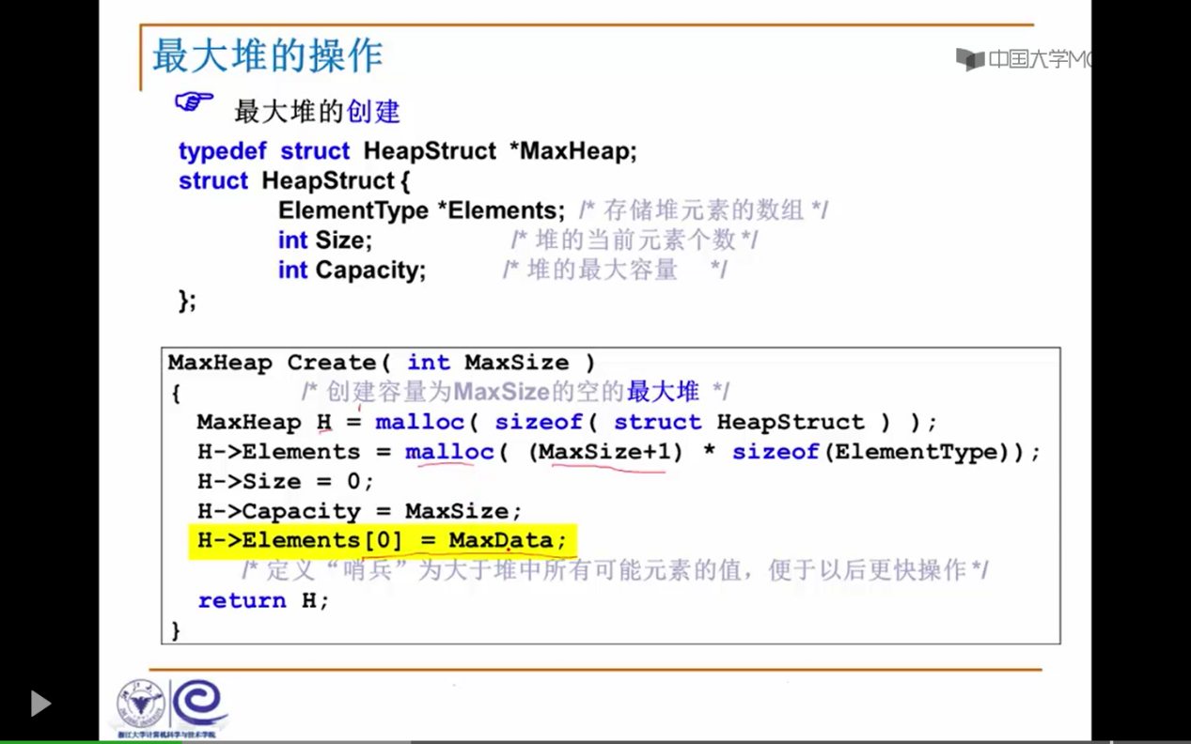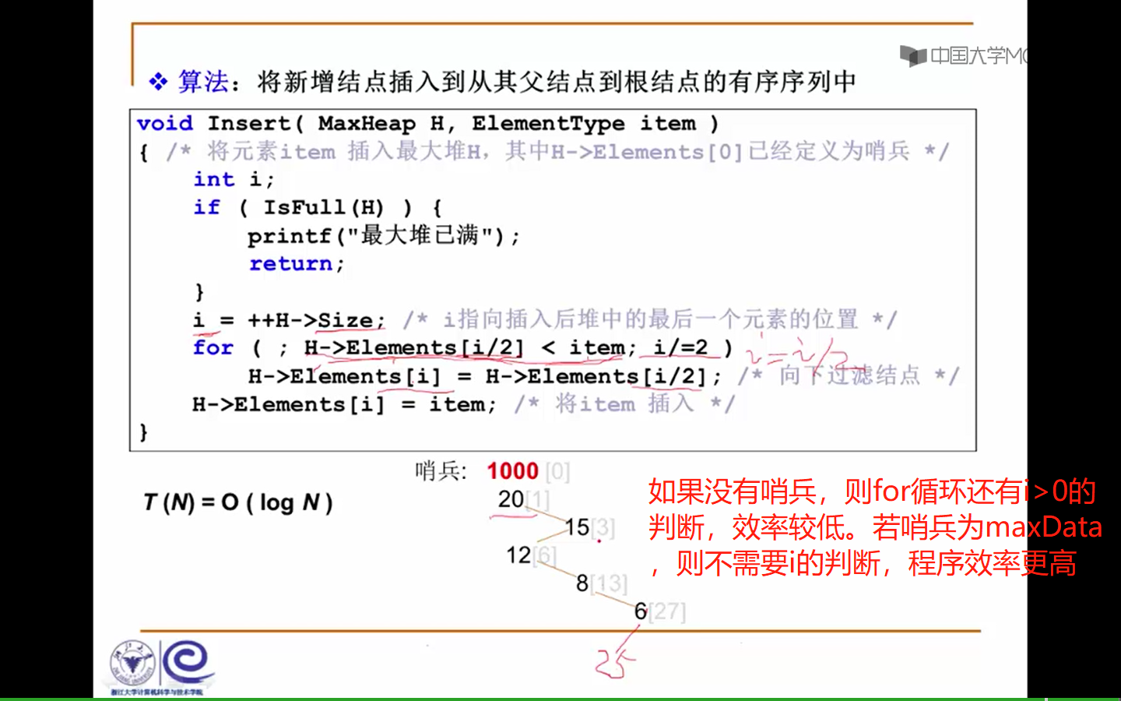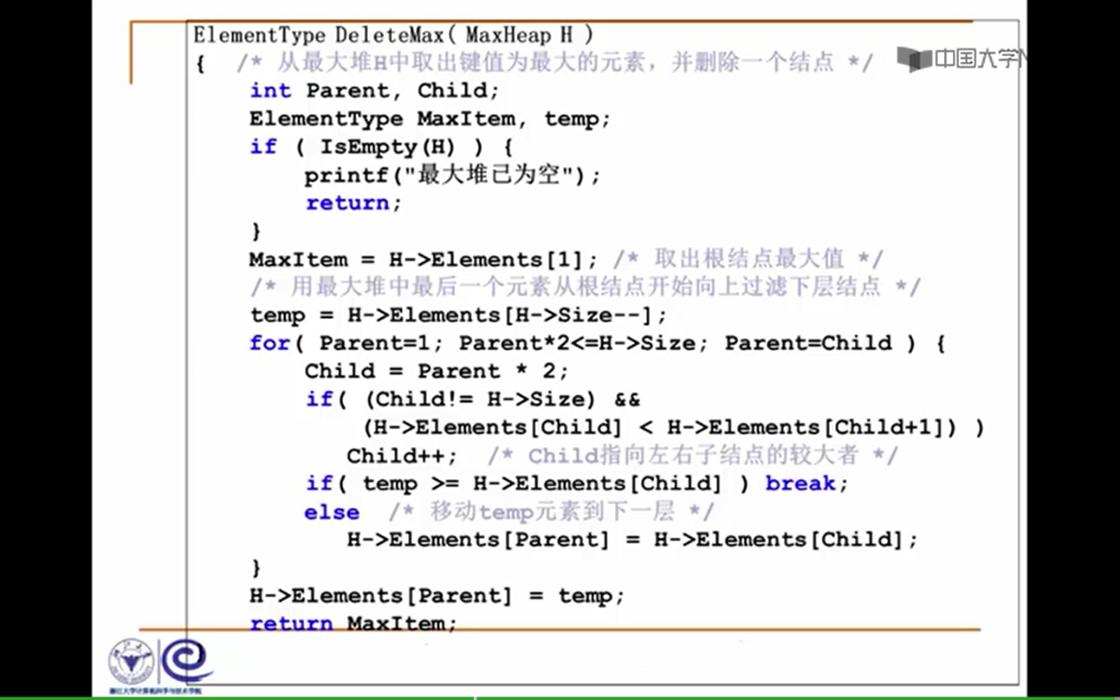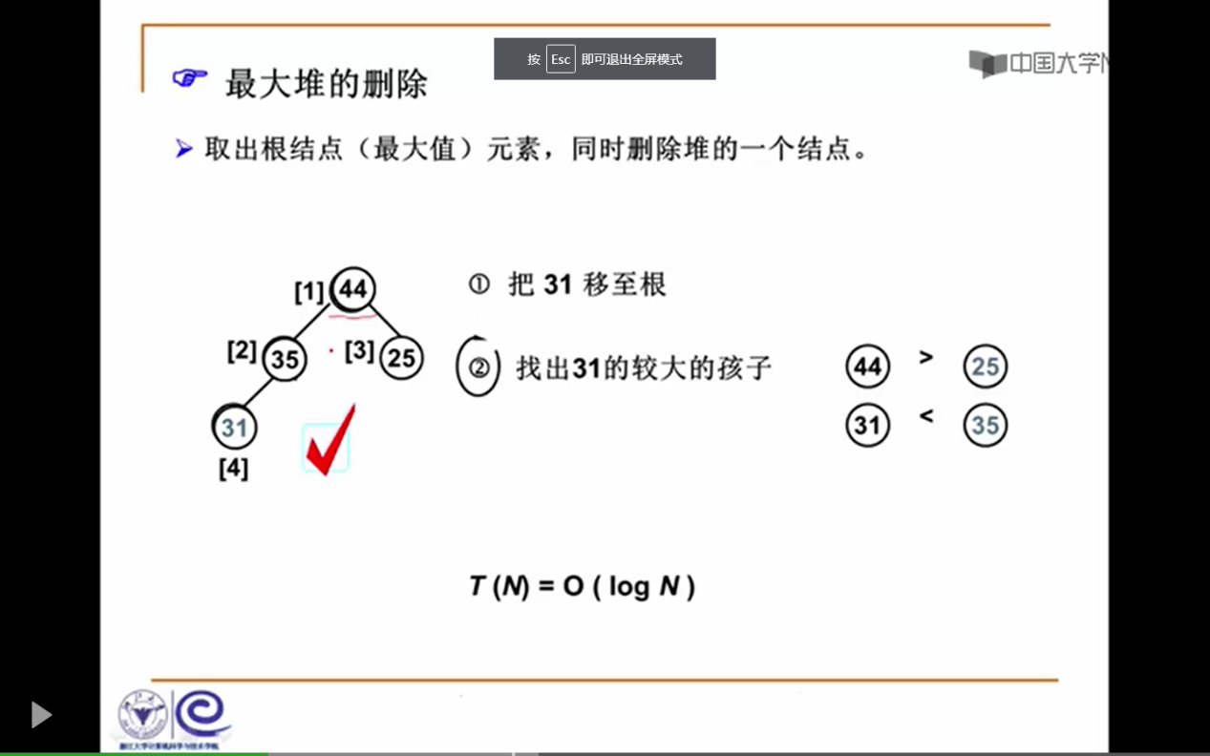

# 哈夫曼树和哈夫曼编码

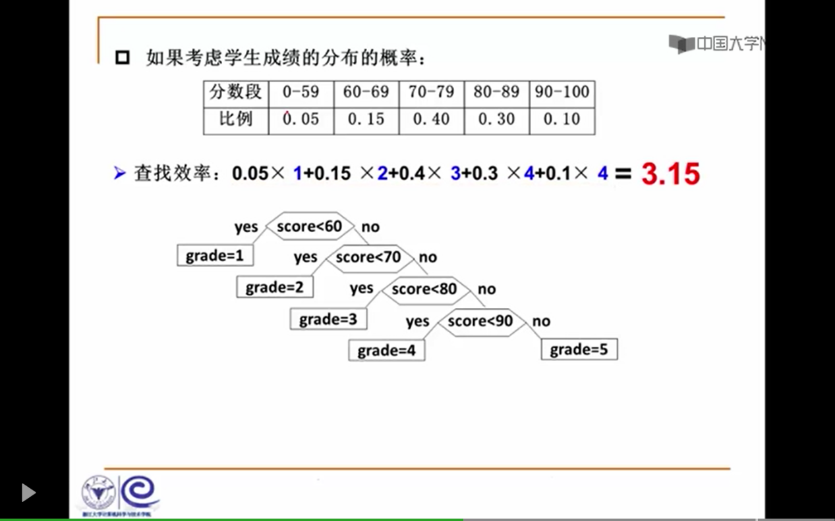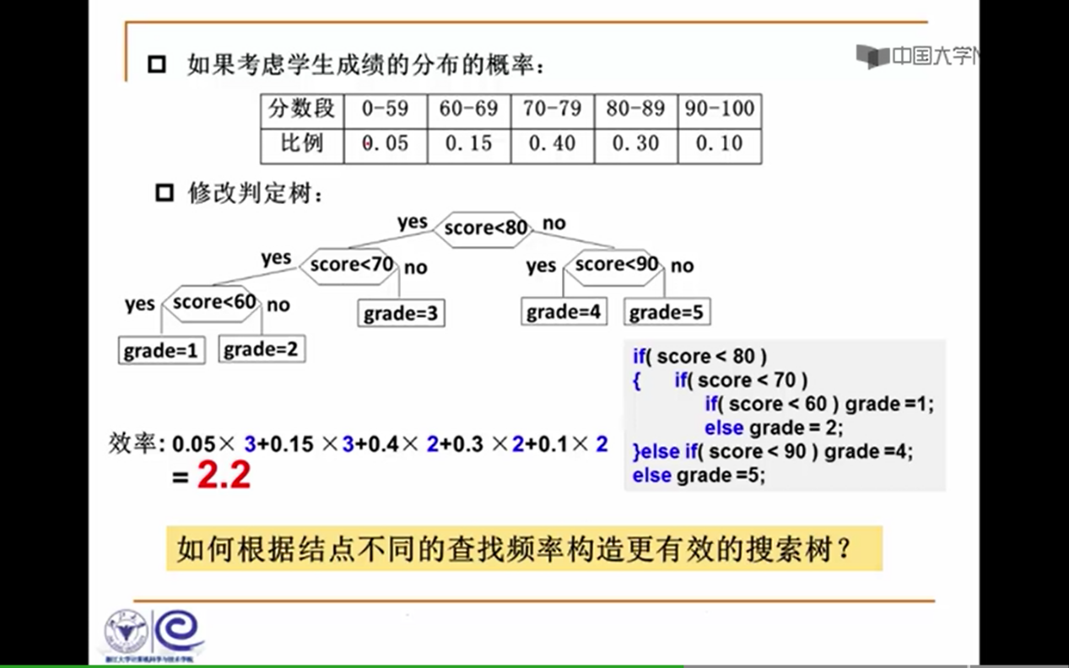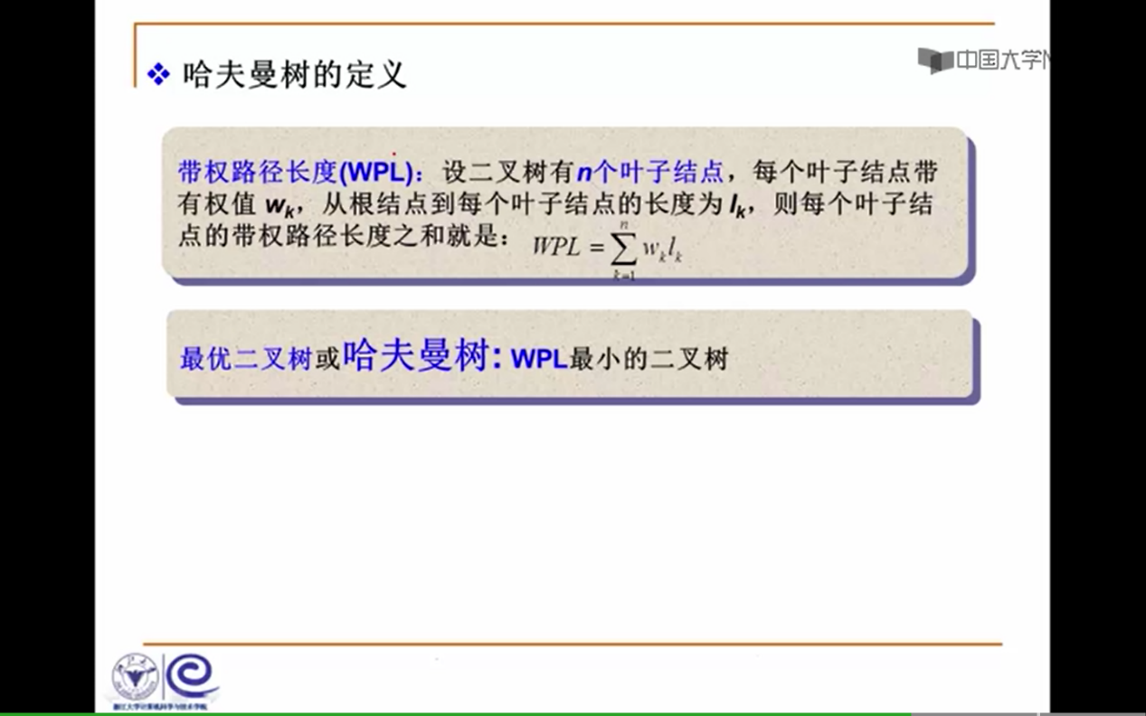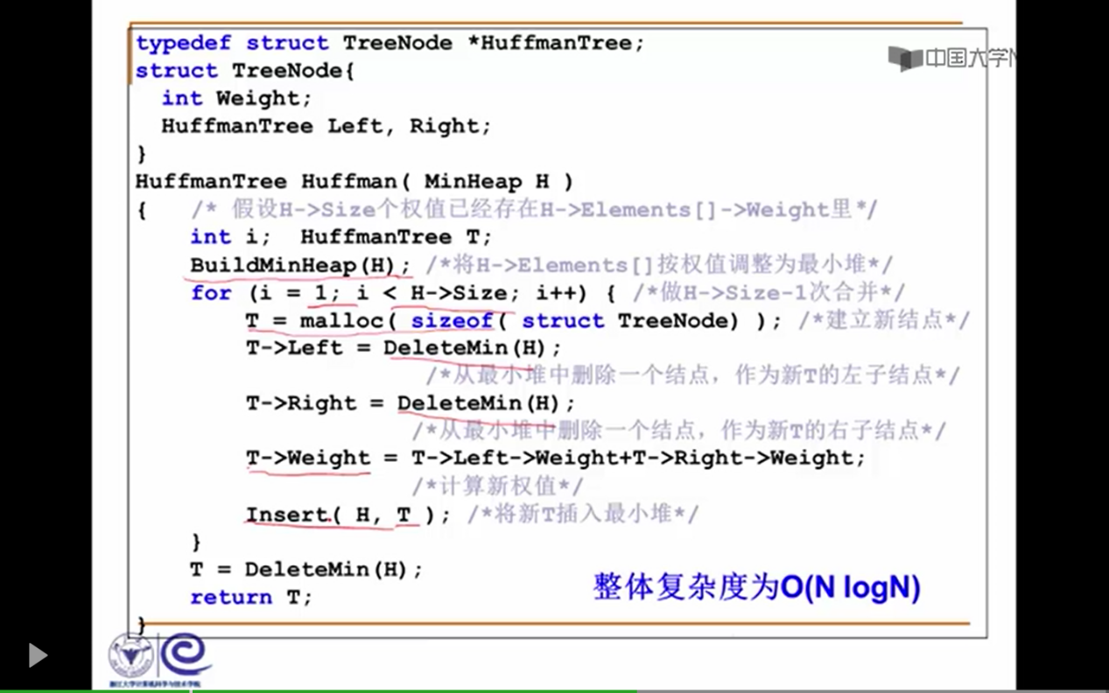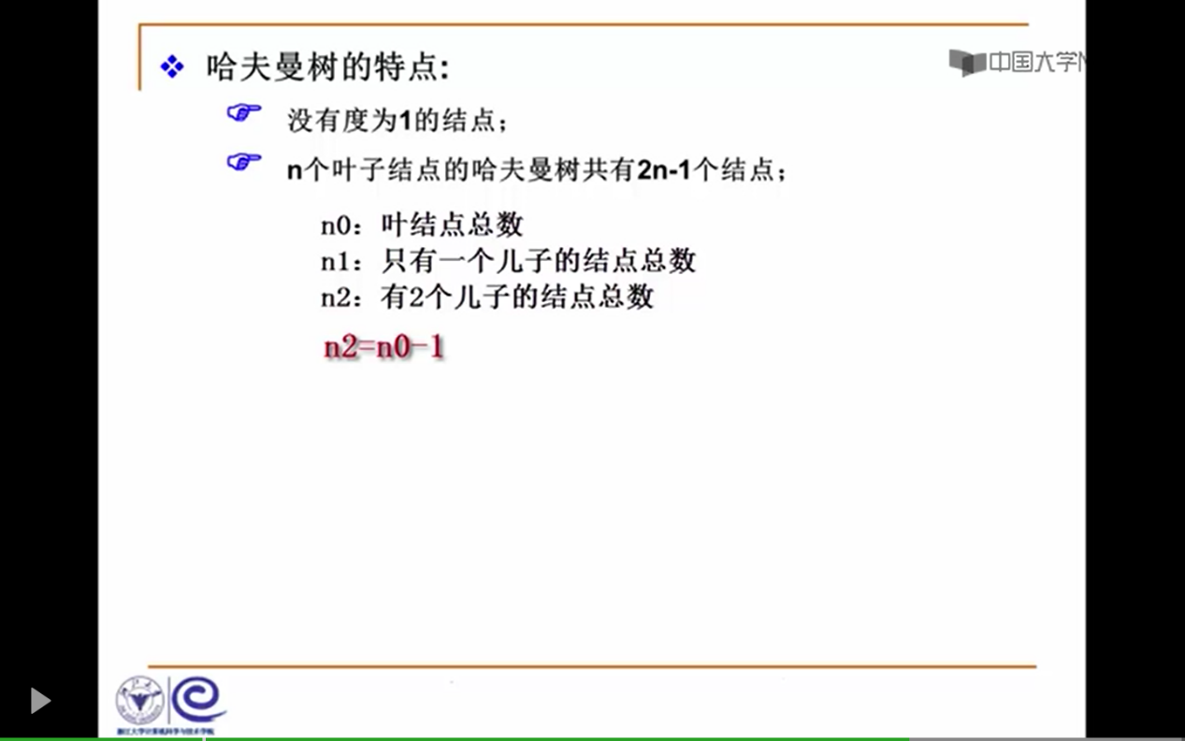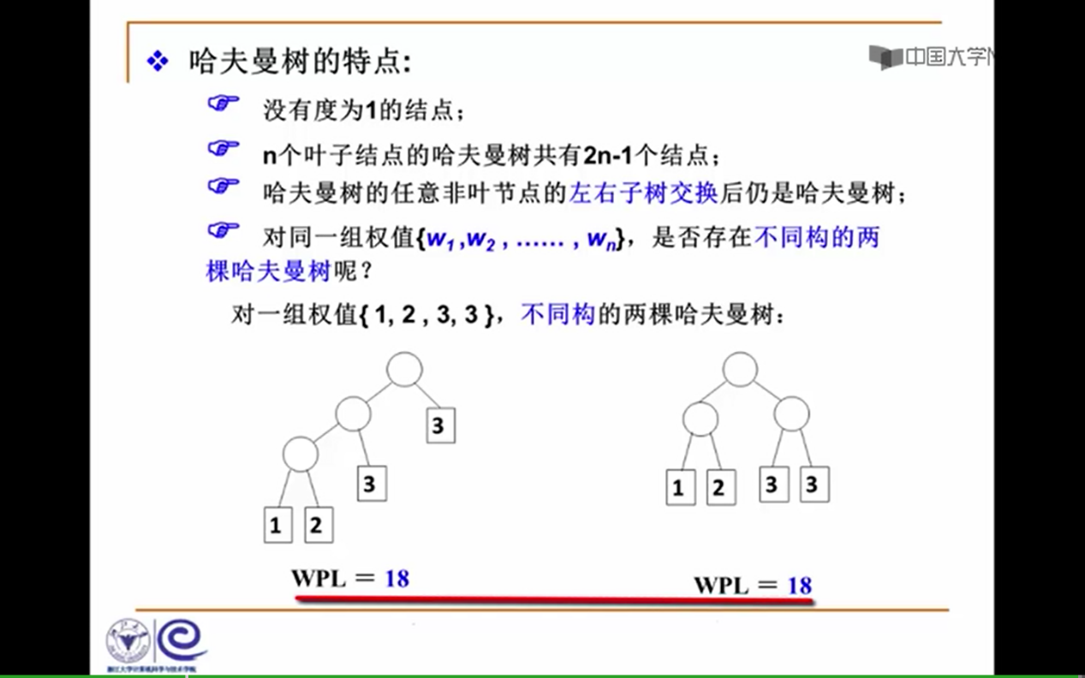

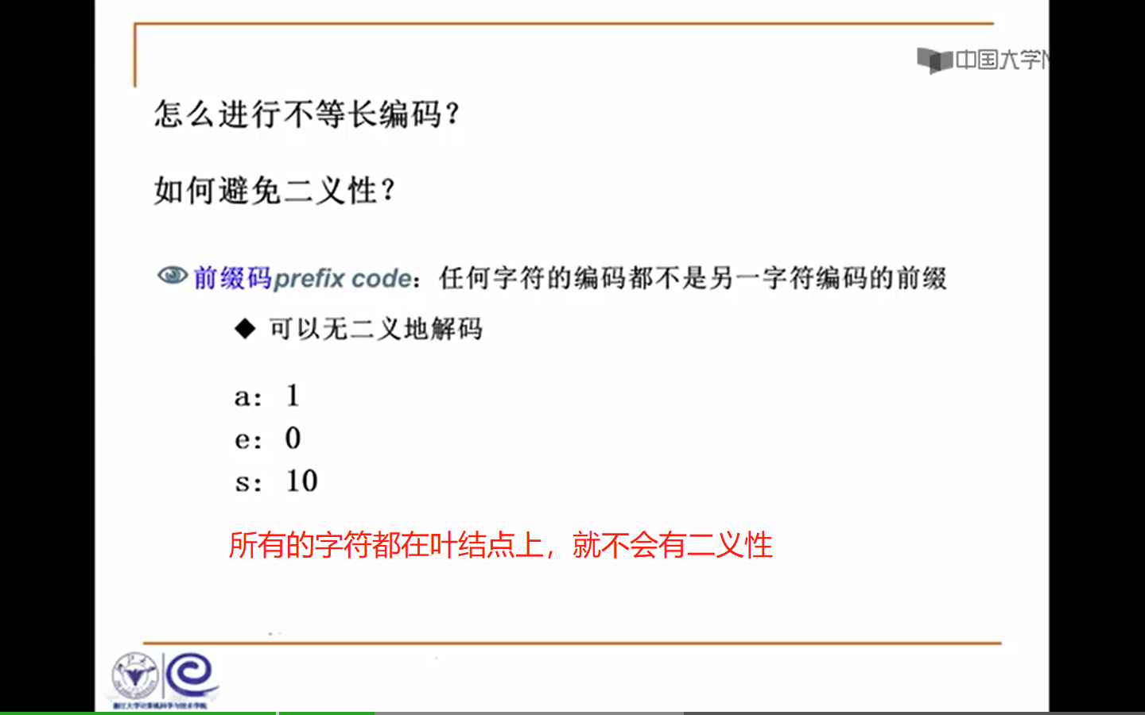

# 集合

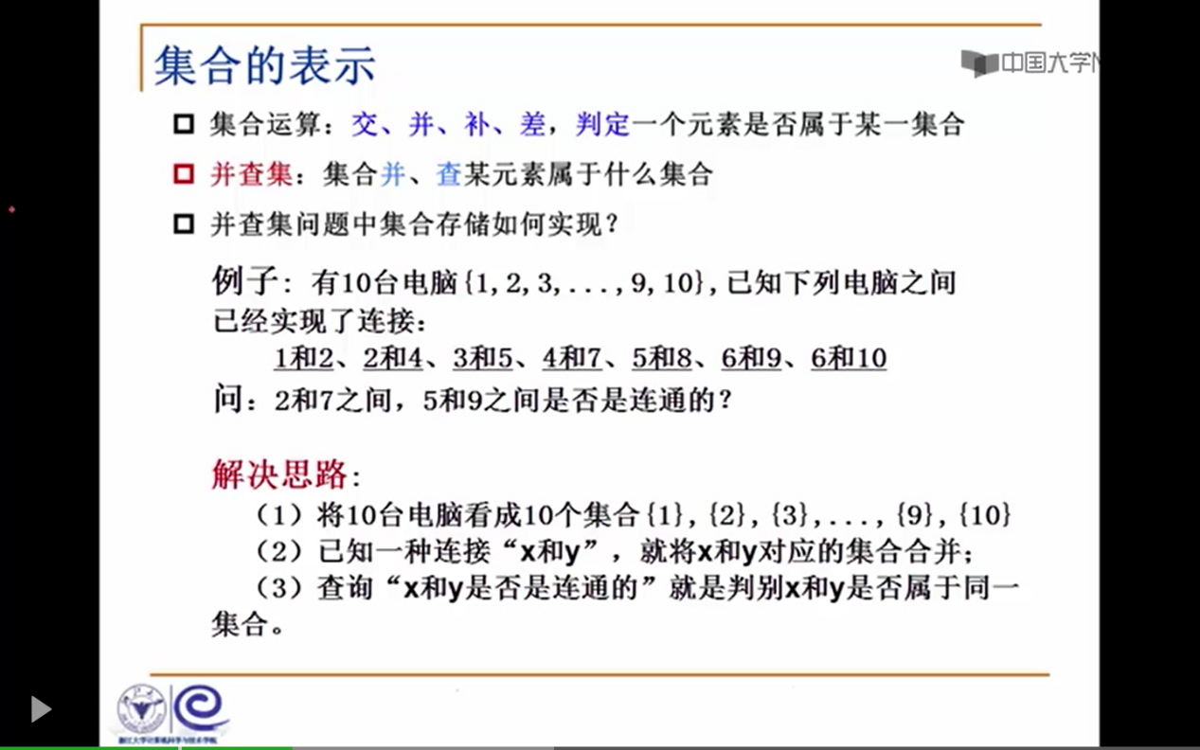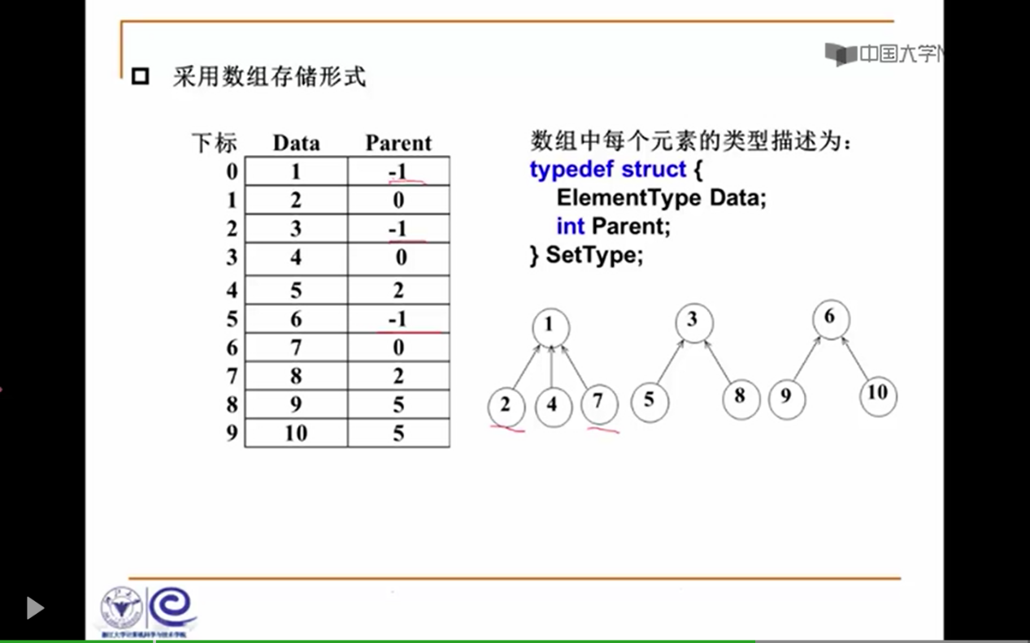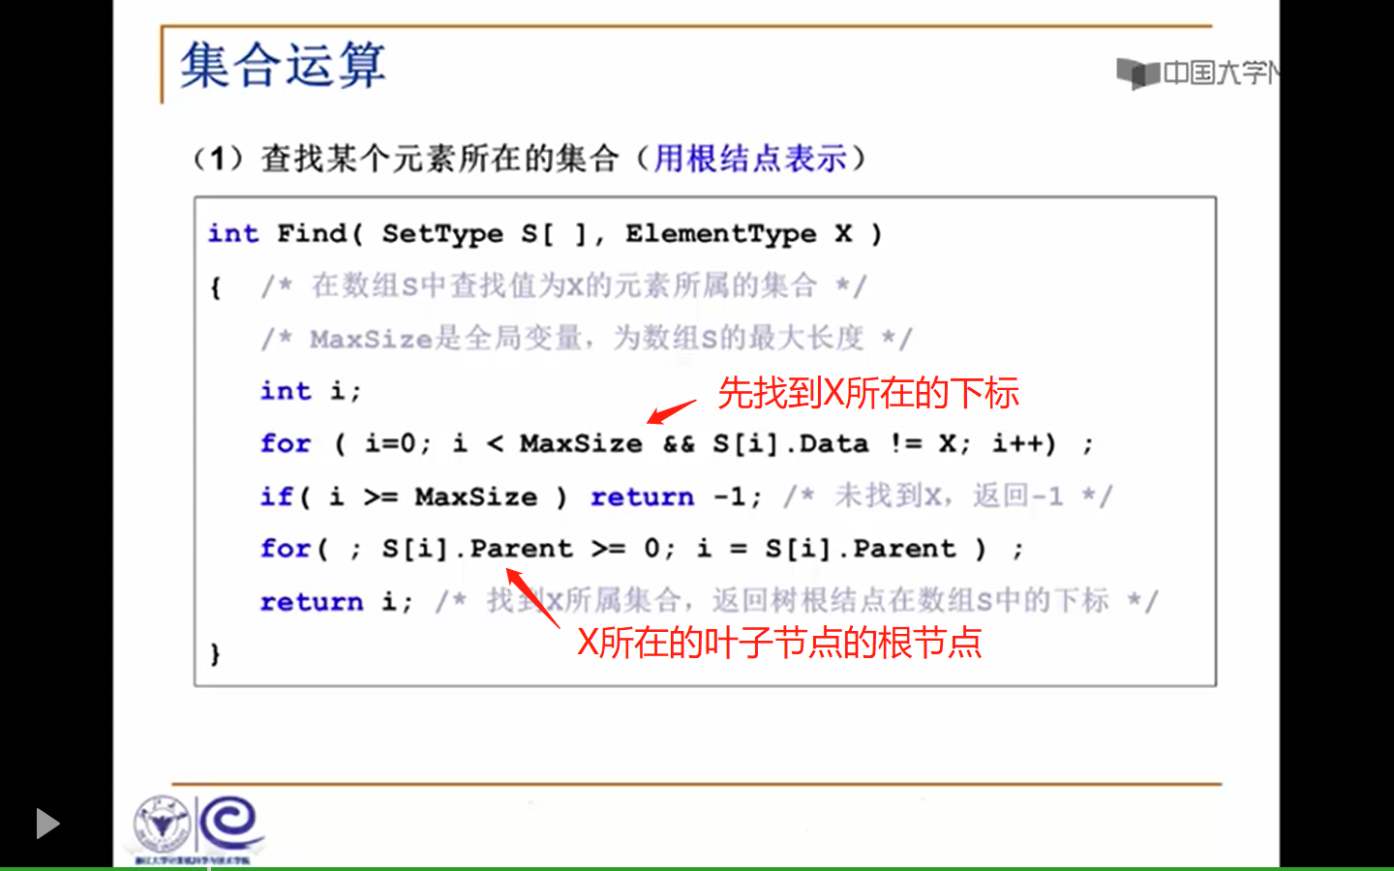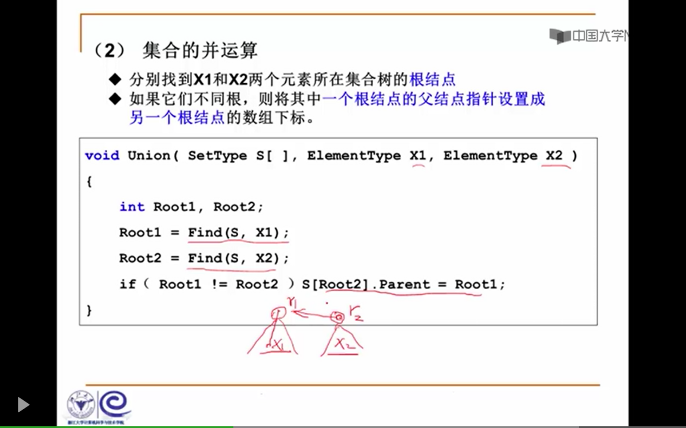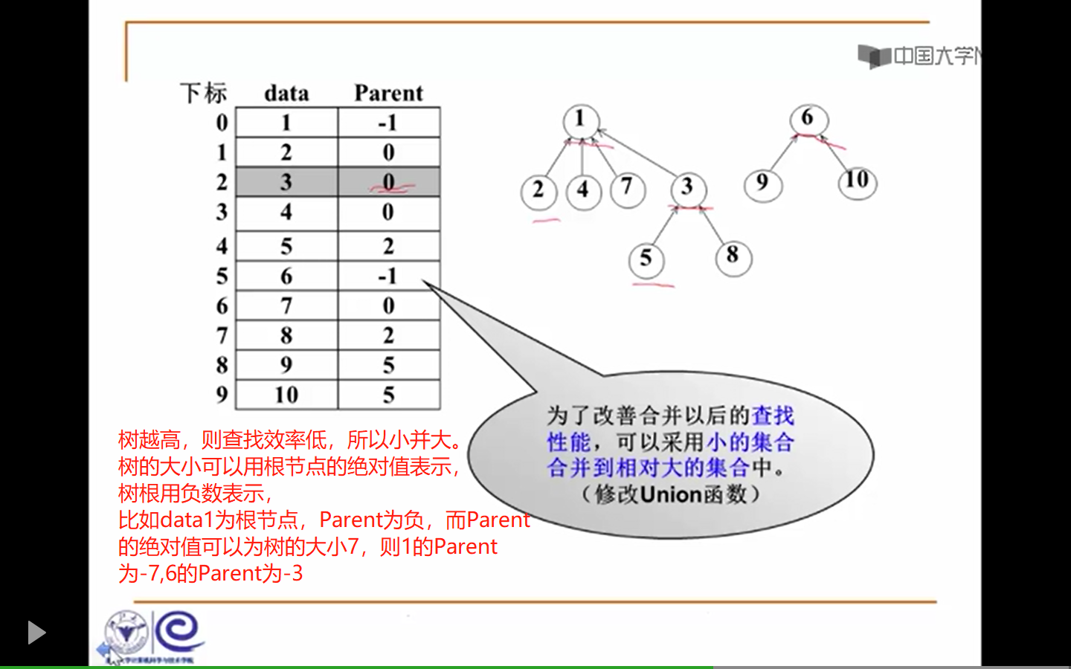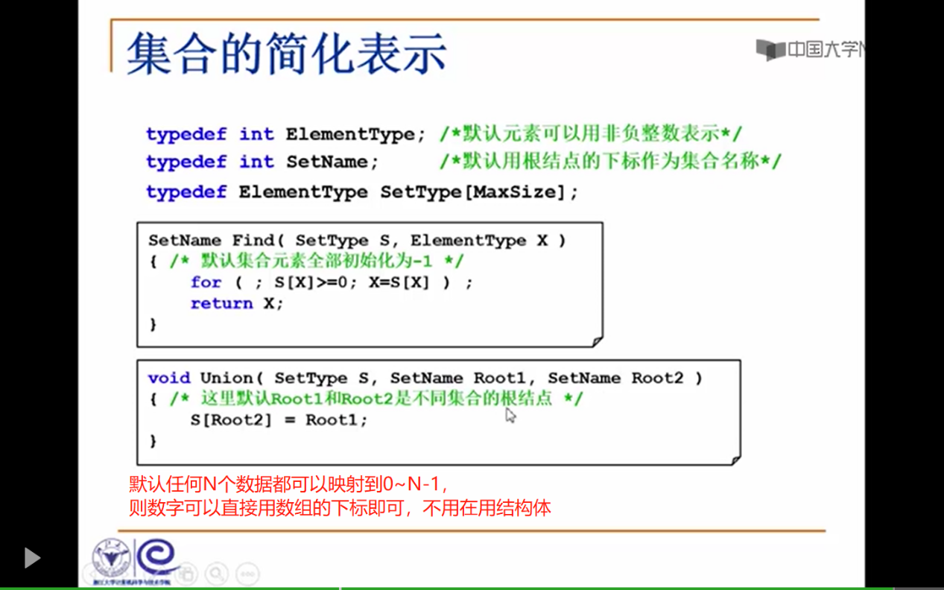

# 图F:\Users\gxf\AppData\Local\Temp\WeChat Files\75f1bd12504d0072230250bce87c1a9.pngF:\Users\gxf\AppData\Local\Temp\WeChat Files\8db288f61bc9bc36c1dba500308801e.pngF:\Users\gxf\AppData\Local\Temp\WeChat Files\f5ac75217fe70eb6a586b4a8d6c22b0.pngF:\Users\gxf\AppData\Local\Temp\WeChat Files\22ee42713ac382215620e522e77d9f5.pngF:\Users\gxf\AppData\Local\Temp\WeChat Files\2ae5c101b7807aea28e7f04fabdf6b1.pngF:\Users\gxf\AppData\Local\Temp\WeChat Files\ff1d6e70bc937735eecebf8ef45e8ab.pngF:\Users\gxf\AppData\Local\Temp\WeChat Files\701f46b370968cb8e1f0625c3cf497b.pngF:\Users\gxf\AppData\Local\Temp\WeChat Files\fe114bfbf685bc81c9dc35dc4f41884.png